PENTAHO ACADEMY · TECHNICAL TRACK
Metadata Similarity
& ML Inference in PDC
Technical Workshop Guide
Configuring the AI engine behind glossary suggestions
Scenario: Arizona Water Company (awc_operations)
Product version: PDC 10.2.11
Audience: Platform administrators, solution architects, technical stewards

Contents

1. Workshop Overview
This workshop covers two tightly related capabilities in Pentaho Data Catalog: the metadata Similarity Score that drives glossary suggestions, and the machine-learning inference layer those suggestions depend on. It is deliberately split from the steward-facing glossary modules because it serves a different audience and a different layer of the platform — the engine room rather than the cockpit.
The motivating question. Open a column such as customer_name in the AWC catalog, switch to Glossary → Suggested, and you may see nothing but “No data to display.” That empty pane is rarely a broken feature. It usually means the similarity job has not run, or the AI/ML layer it relies on has not been configured. By the end of this workshop you will be able to make both true.

Who this is for
- Platform administrators who own the PDC deployment and its environment configuration.
- Solution architects designing how governance and AI features fit together.
- Technical data stewards who run similarity and curate the resulting suggestions.

Prerequisites
- A running PDC 10.2.x environment with at least one connected data source (the AWC awc_operations schema is used throughout).
- Access to the deployment’s environment configuration (the conf/.env layer).
- An inference endpoint you can point PDC at — a local model server or a hosted, OpenAI-compatible API. This guide stays backend-agnostic.
- Familiarity with PDC glossaries, terms, and the term-to-column link (covered in the Glossaries module).

Learning objectives
- Explain what the metadata Similarity Score is and how it is produced.
- Run the similarity process and review suggestions across columns, tables/files, and terms.
- Tune the score threshold and apply the approve/reject workflow responsibly.
- Stand up the ML inference layer and verify it end to end.
- Diagnose an empty Suggested pane using a repeatable troubleshooting chain.

Where it fits in the Technical Track
Place this module alongside Data Identification, Build-Your-Own, and the Glossary Generator App. Part A (the Similarity Score) is steward-facing and can be taught on its own. Part B (ML inference) is administrator-facing and doubles as a platform prerequisite — the same AI/ML layer also powers the PDC chatbot, so configuring it once benefits more than the similarity feature.

2. The Concept: ML-Driven Metadata Similarity
Metadata similarity uses machine learning to identify and suggest similar tables, columns, and business terms across the data landscape. Rather than matching on column names alone, it scores candidates on metadata structure and meaning, so semantically equivalent fields can be matched even when their names differ. The practical payoff is threefold: more consistent term tagging, less duplicated effort, and a direct contribution to data trust.
Key idea
Similarity is a batch process, not a live lookup. Suggestions appear only after the similarity job has run. Opening the Suggested pane does not generate matches — it displays the results of the most recent run.
PART A
Working with the Similarity Score

3. Running the Metadata Similarity Process
Run the process from the administration area before expecting any suggestions to appear:
- Open Management. From the left navigation, choose Management to open the Manage Your Environment page.
- Configure Similarity. On the Metadata Similarity card, click Configure Similarity to open the Metadata Similarity Configuration page.
- Select scope. Choose the databases to analyze. Optionally select one or more business terms to focus the run.
- Apply. Click Apply. The metadata similarity process (handled by the Miscellaneous Jobs Worker) begins.
- Monitor. Track the run on the Workers page until it completes; only then will suggestions populate.
Remember
The run is the prerequisite that everything else depends on. With no completed run, the Suggested pane stays empty no matter how you set the threshold.

4. Reviewing Suggestions
Once a run completes, suggestions surface in three places depending on what you select:
You select | Where to look | What approval does
A column | Glossary tab → Suggested pane | Assigns the matched term to the column; it then appears under Elements.
A table or file | Similar Items tab | Updates the suggestion’s status in place.
A business term | Data Elements tab | Assigns the term to the matched column.

In every case the list shows each candidate with a similarity score and a status. Higher scores indicate a stronger match based on metadata structure and meaning.

5. Score Threshold Mechanics
The Suggested and Similar Items lists contain only items whose similarity score is above the threshold, which defaults to 0.5. Adjust the Score Threshold box and click Submit to re-filter:
- Lower the score to see more, more loosely matched items.
- Raise the score to see fewer, more closely matched items.
Common misconception
The threshold filters an already-computed result set — it does not generate matches. Lowering it to 0.2 still shows nothing if the similarity job never ran. Tune the score to read results, not to create them.

6. The Approve / Reject Workflow
Review each suggestion and act on it with the checkboxes:
- Approve accepts the match. On a column’s Suggested pane, approval assigns the term to the column.
- Reject discards the suggestion from the current list.
Caution — reject is permanent
A rejected item is excluded from future similarity suggestions for that asset. Reject deliberately to remove genuinely wrong matches, not as a quick way to clear a cluttered list.
You can also use the Show Approved and Show Rejected filters to revisit prior decisions.

7. How Suggestions Feed the Trust Score
The calculated Trust Score weighs four inputs. Approving a similarity suggestion flips one of them from absent to present:
Trust Score input | What it measures
Data Quality | Completeness, accuracy, validity, uniqueness, consistency
User Ratings | 1–5 star input from data consumers
Data Lineage | Whether lineage is verified
Glossary Term | Whether a term is assigned — set when you approve a suggestion

AWC example. Approve a strong match for customer_name and that column’s table earns the glossary-term credit on its next Trust Score calculation — the AI-assisted path to the same term-to-column link you would otherwise create by hand.

8. Lab A — Suggesting a Term for customer_name
- Run similarity. From Management → Metadata Similarity → Configure Similarity, select the awc_operations database and click Apply. Wait for the Workers page to show completion.
- Open the column. In Data Canvas, navigate to AWC Operations → Customers → customer_name, then open the Glossary tab and select the Suggested pane.
- Tune the threshold. Start at 0.5. If you see nothing, lower it and Submit to widen the result set.
- Approve. Select a high-scoring, correct match and click Approve. Confirm the term now appears on the Elements pane.
- Confirm trust impact. Re-run the Trust Score calculation for the parent table and note the glossary-term input is now satisfied.
PART B
Setting Up ML Inference

9. The AI/ML Architecture
Similarity scoring and the PDC chatbot share one machine-learning layer. Three services do the heavy lifting:
Service | Role
ml-gateway-service | Routes ML requests to the configured inference backend.
psc-ml-models | Manages ML model metadata and the similarity workload.
pdc-chatbot-backend | Shares the same layer — configured once, benefits both features.

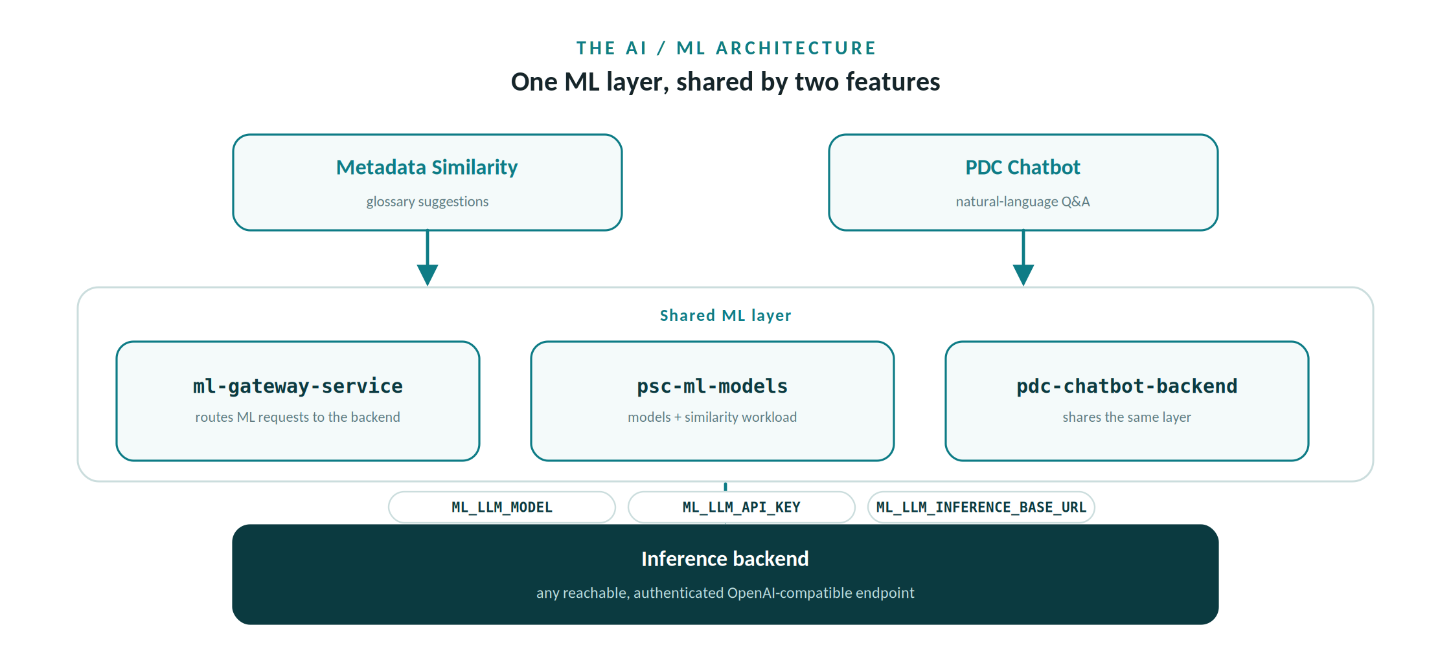
Two features share one ML layer, pointed at any OpenAI-compatible backend through three variables.

10. Service Profiles
None of the ML services deploy unless their profiles are active. Confirm that COMPOSE_PROFILES includes both ml-models and ai-ml (alongside the other profiles your deployment uses). If these are absent, the similarity and inference services simply never start — a frequent root cause of an empty Suggested pane.

11. The Inference Configuration
Three environment variables connect PDC to your inference backend. All three are empty by default and must be populated when using external LLM services:
Variable | Purpose | Default
ML_LLM_MODEL | The model identifier your backend serves. | (empty)
ML_LLM_API_KEY | Credential for the inference service. | (empty)
ML_LLM_INFERENCE_BASE_URL | The endpoint PDC calls for inference. | (empty)

Backend-agnostic by design
Point these three values at whatever OpenAI-compatible endpoint you operate — a self-hosted model server or a hosted API. PDC does not care which provider you choose, only that the three values resolve to a reachable, authenticated endpoint.

12. Supporting ML Parameters
These tune behavior once a backend is connected. The defaults are sensible to start; revisit them when you know your model and typical document sizes:
Variable | Default | Meaning
ML_CUSTOM_TOKENS | 6000 | Token limit for an ML operation
ML_TOKEN_WINDOW_SIZE | 8000 | Context window size for the model
PDC_WS_DEFAULT_MAX_FILE_SIZE_FOR_ML | 10 MB | Largest file sent for ML processing
ML_BENTO_TIME_OUT | 6000 | Serving timeout before a run gives up

13. Where Configuration Lives
Defaults ship in .env.default. Override sensitive or environment-specific values in your client configuration layer (the conf/.env file referenced by PDC_CLIENT_PATH). Keep secrets such as ML_LLM_API_KEY out of the defaults and managed through your environment’s secret-handling practice.

14. Verifying the Setup
- Profiles. Confirm ml-models and ai-ml are active and the ML services are running.
- Inference values. Confirm all three ML_LLM_* variables are populated.
- Reachability. From the PDC host, confirm the inference base URL is reachable and authenticates.
- End-to-end. Run similarity, watch the Workers page, then confirm the Suggested pane populates for a known column.

15. Troubleshooting the Empty Suggested Pane
Walk the chain from top to bottom. The first check that fails is almost always the cause:
# | Check | If it fails
1 | ml-models and ai-ml profiles active? | Enable the profiles and redeploy the stack.
2 | All three ML_LLM_* values populated? | Set the model, key, and base URL.
3 | Inference endpoint reachable from PDC? | Fix networking, DNS, or credentials.
4 | Similarity job completed on Workers page? | Run it from Management → Configure Similarity.
5 | Threshold not set too high? | Lower the score and click Submit.
6 | Suggestions not all previously rejected? | Past rejects are excluded permanently; re-run scope or check another asset.
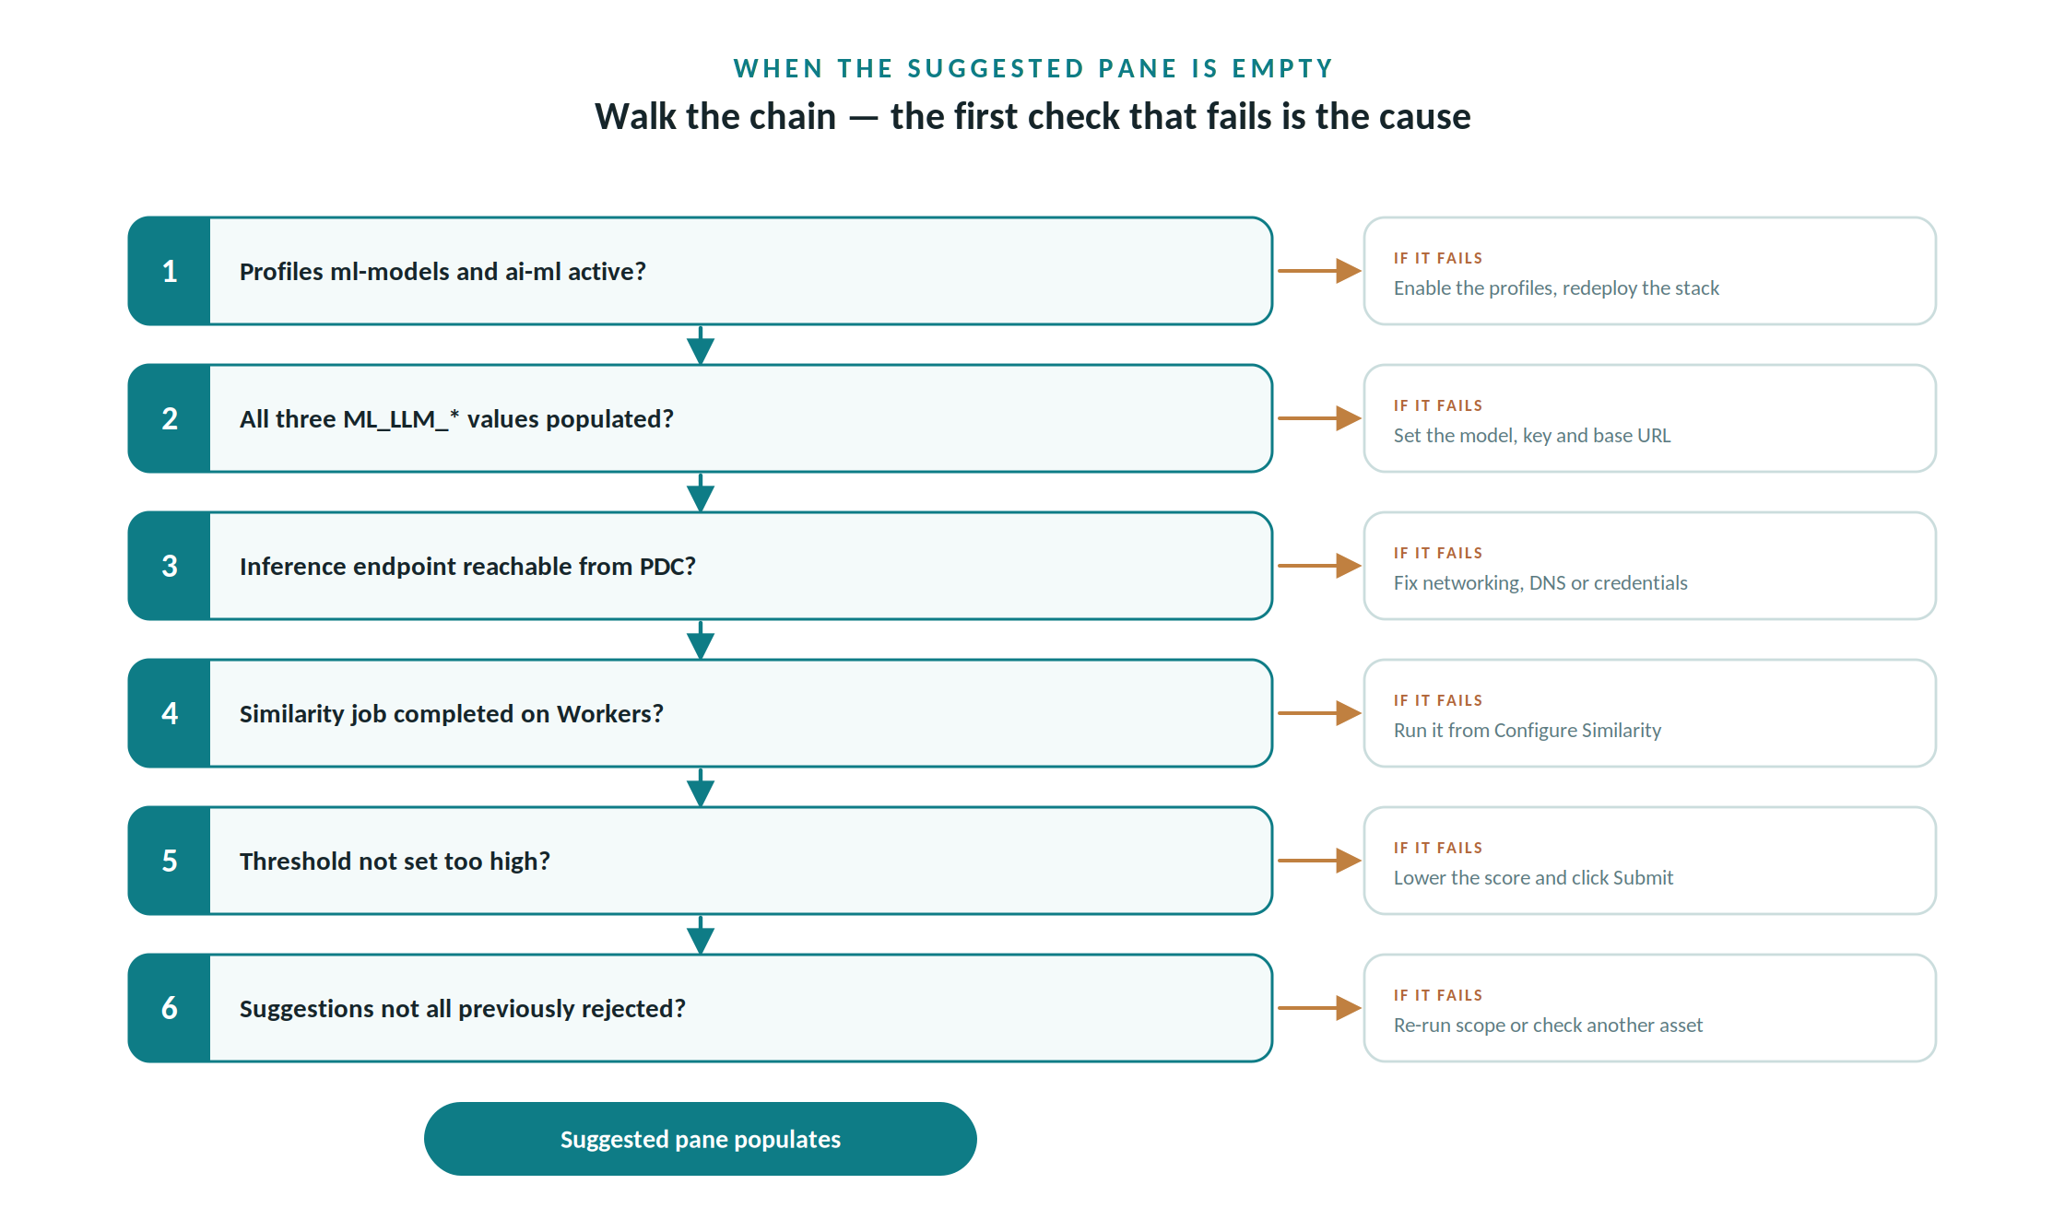
Diagnose top-to-bottom: the first failing check is almost always the cause.

16. Lab B — Wiring Inference and Confirming Suggestions
- Enable profiles. Ensure ml-models and ai-ml are in COMPOSE_PROFILES; redeploy if you changed them.
- Set inference. Populate ML_LLM_MODEL, ML_LLM_API_KEY, and ML_LLM_INFERENCE_BASE_URL for your chosen backend.
- Verify reachability. Confirm the PDC host can reach and authenticate against the endpoint.
- Re-run similarity. Run the process across awc_operations and wait for completion.
- Confirm. Reopen customer_name → Glossary → Suggested and verify matches now appear. The empty pane from the cold open is resolved.

Appendix A — ML Configuration Reference
Variable | Default | Notes
COMPOSE_PROFILES | — | Must include ml-models and ai-ml.
ML_LLM_MODEL | (empty) | Model identifier; set for external LLM services.
ML_LLM_API_KEY | (empty) | Credential for the inference service.
ML_LLM_INFERENCE_BASE_URL | (empty) | Inference endpoint URL.
ML_CUSTOM_TOKENS | 6000 | Token limit per ML operation.
ML_TOKEN_WINDOW_SIZE | 8000 | Context window size.
PDC_WS_DEFAULT_MAX_FILE_SIZE_FOR_ML | 10485760 | Max bytes (10 MB) per file for ML.
ML_BENTO_TIME_OUT | 6000 | ML serving timeout.

Variable names are stable across the PDC 10.2.x line; confirm exact values against your deployment’s configuration files.

Appendix B — Facilitator Checklist
- Environment reachable; AWC awc_operations source connected.
- ml-models and ai-ml profiles active before the session.
- Inference backend chosen and the three ML_LLM_* values set.
- One similarity run completed in advance as a known-good demo.
- customer_name identified as the live worked example.

